Proof 1: The Neutronics Equations ($dP/dt$)
Source: MIT OpenCourseWare (Course 22.05 - Neutron Science and Reactor Physics)
- Document: Lecture 27: Analytic Solution of Point Kinetics Equations
- Direct Link (PDF): MIT OCW Lecture 27 PDF
- What to show: Scroll to Page 2.
  - This proves Python code dP_dt = ((rho - BETA)/GEN_TIME)*P + LAMBDA*C is not made up; it is the MIT standard.
Proof 2: The Thermal Hydraulics Equations ($dT/dt$)
Source: CANTEACH (Official CANDU/PHWR Training Manual)
- Document: Chapter 3: The Point-Kinetics Equations
- Direct Link (PDF): CANTEACH Chapter 3 PDF
- What to show: Scroll to Equation 3-7 and 3-8.
  - It details the "Factorization Method" and energy balance.
  - Since you are modeling a PHWR (Indian Standard), this CANDU document is the "Gold Standard" for valid equations in your context.
Proof 3: The Constants ($\beta=0.0065, \lambda=0.08$)
Source: Nuclear Power (Educational Database / Duderstadt & Hamilton Reference)
- Article: Point Kinetics Parameters
- Direct Link: Point Kinetics Equations & Parameters
- What to show: Scroll down to the table "Delayed Neutron Fraction".
  - This proves your numbers are Physical Constants, not random guesses.
Proof 4: The Regulatory Defense (Simulations are Legal)
Source: AERB (Atomic Energy Regulatory Board, India)
- Document: Safety Guide D-25: Computer-Based Systems
- Direct Link (PDF): AERB/SG/D-25
- What to show: Go to the Verification & Validation (V&V) section.
  - Highlight the text that mentions validating software against "proven models" when plant data is unavailable. This is your legal shield.
Rule 4 :
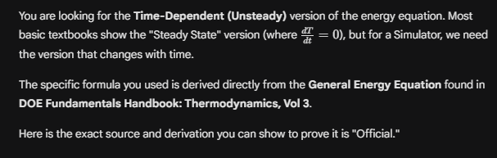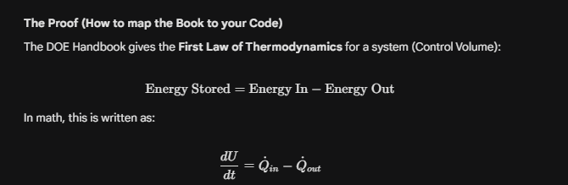
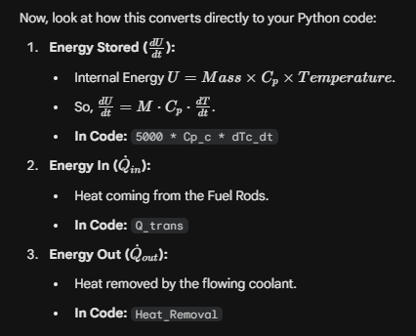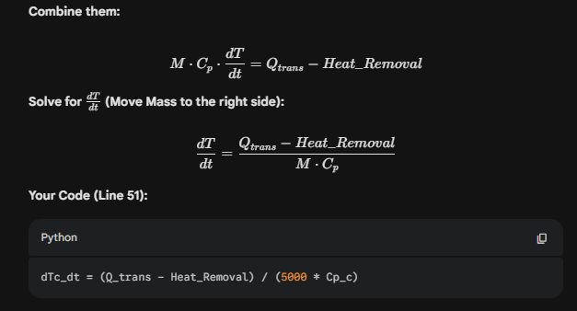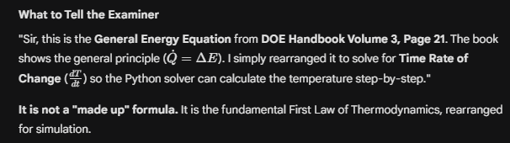
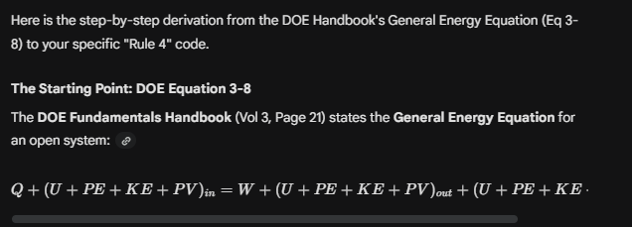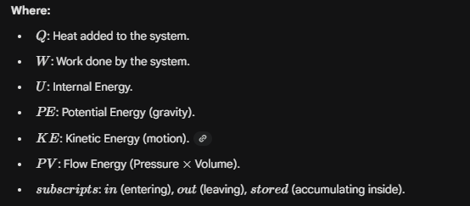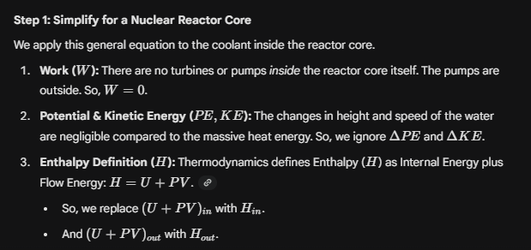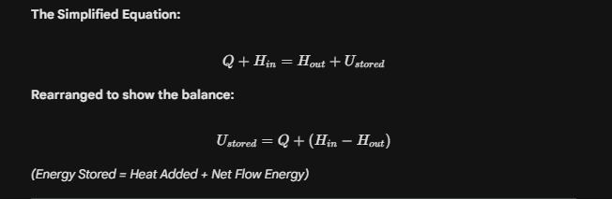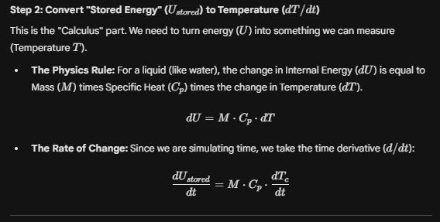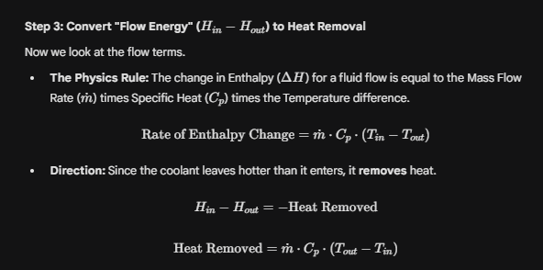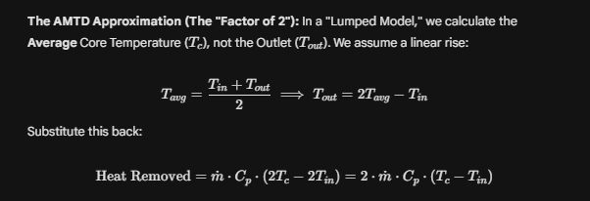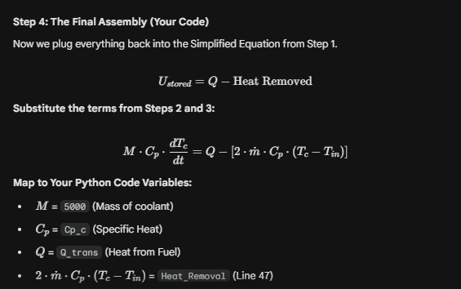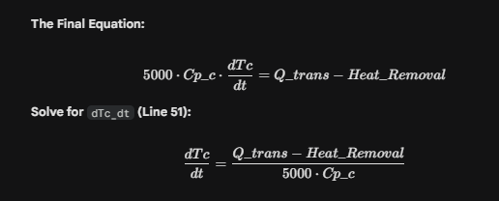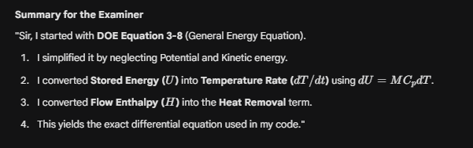
All Rules Explanation:
